JobMatch AI Chrome Extension
Khanh Nguyen

Objective
Job searching has become increasingly time‑consuming as AI‑generated postings and high‑volume listings make it harder to quickly assess fit. While LinkedIn offers a built‑in skill‑matching feature, most major job boards, such as Workday, do not. This project fills that gap by providing a Chrome extension that brings LinkedIn‑style skill matching to multiple platforms.

Architecture
The system is built on a lightweight four‑layer architecture (see Figure 1). At the top is the User layer, where job seekers browse postings across supported job boards. The Extension layer powers the in‑browser experience: it extracts job descriptions from the page, provides the side‑panel interface, and coordinates communication with the backend. The Backend layer consists of a Cloudflare Worker that routes requests, enforces rate limits, and securely proxies calls to the AI model. At the core, the AI layer uses Groq’s Llama 3.3 70B model to analyze the resume and job description, generate match scores, identify skill gaps, and produce ATS‑optimized resume content.

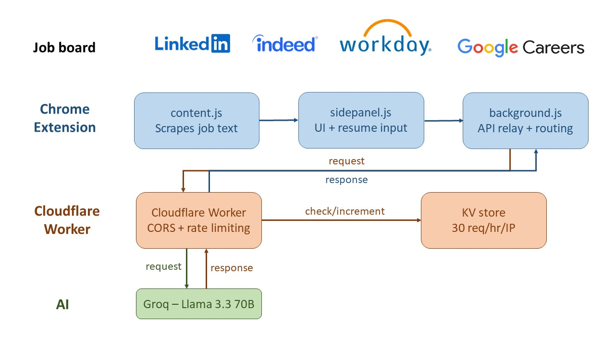
Figure 1. Architecture Overview.
The system consists of four layers: user/job board, Chrome extension, Cloudflare Worker backend, and Groq‑powered AI processing.

Key Features
JobMatch AI provides a streamlined interface with three core features (see Figure 2). The Match tab analyzes a user’s resume against any job description, offering an instant match score and skill breakdown, with automatic job-description scraping on supported platforms. The ATS Writer generates optimized resume sections — such as summaries, bullet points, and skills — using the user’s saved resume and the current job posting, with multiple tone options for different application styles. The History tab stores past analyses, allowing users to revisit results and compare how their fit varies across roles over time.
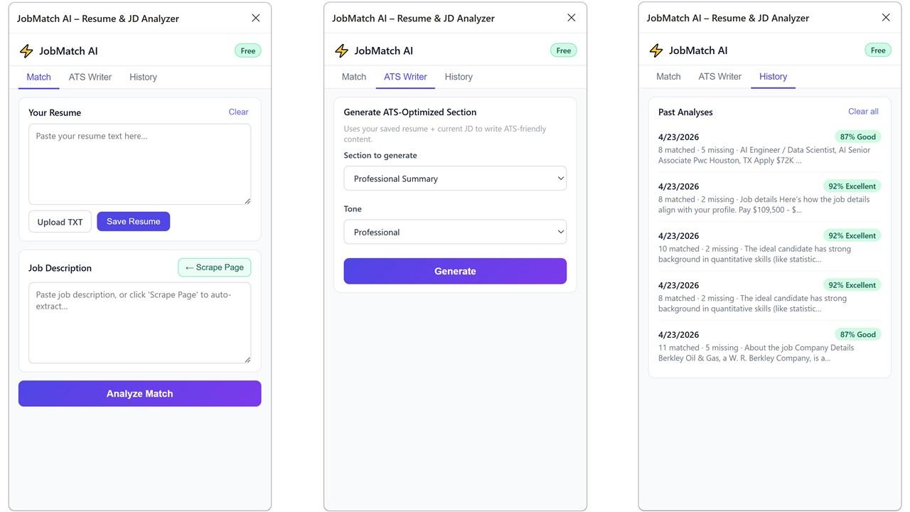
Figure 2. The UI has three tabs: Match (left) for resume–JD analysis, ATS Writer (middle) for generating optimized sections, and History (right) for past results.

Conclusion
JobMatch AI closes a critical gap in today’s job‑search ecosystem by bringing instant skill matching and ATS‑optimized rewriting to platforms that lack these capabilities. The project highlights the power of combining a Chrome extension, a serverless backend, and Groq‑accelerated LLMs to deliver real‑time insights with minimal cost. With its modular design, the system is well‑positioned for future expansion, including broader platform coverage and more advanced resume‑generation features.

